Enhanced Classification and Detection of Brain Tumor using Hybrid Deep Learning and Machine Learning Models.

Sireesha Moturi1, Divvela Bala Sri Abhigna2, Gaddam Saranya3, Shaik Sameera4, Chinnam Harini5, and Dodda Venkata Reddy6

1*,*2*,*3*,*4*,*5*,*6 Department of Computer Science Engineering, Narasaraopeta Engineering College, Narasaraopet, India.

[*sireeshamoturi@gmail.com,](mailto:sireeshamoturi@gmail.com) abhidiveela@gmail.com,

gaddamsaranya4@gmail.com, [sameerashaik22498@gmail.com,](mailto:sameerashaik22498@gmail.com)

chinnamharini30@gmail.com, [doddavenkatareddy@gmail.com](mailto:doddavenkatareddy@gmail.com)

**Abstract:** deep learning has become an influential tool in medical imaging, especially the present work illustrates a new technique for brain tumor identification based on magnetic resonance im- ages(MRI) using the goodness of convolutional neural networks and support vector machine techniques. The proposed model combines CNNs performing feature extraction effectively, while SVMs classify with high precision. To begin with, some preprocessing methods like adaptive gamma correction, adaptive contrast enhancement, and median filtering are ap- plied to MRI images so as to improve image quality and minimize noise interference. Fuzzy c-means clustering technique is used to extract important texture features like energy, mean values or entropy from GLCM represented as matrices of grey levels co-occurrence pairs. CNN helps with acquiring deeper features from segmented images which serve as inputs during training phases of SVM classifiers based on those features thus obtained from them (CNN), eventually yielding high performance levels. An hybrid model using CNN-SVM showed an accuracy rate of 97 .94%, sensitivity 95% , specificity 98.1% when it came to distinguishing between normal and abnormal brain tissue. Therefore, this hybrid model demonstrates its capability in tumor detection due to combination of both CNN and SVM hence providing an alternative automated approach for early diagnosis.

**Keywords:** Magnetic Resonance(MRI) Images, Fuzzy c-means

Segmentation, CNN- SVM Hybrid Model, GLCM Feature Extraction

# Introduction

Among the most terrible types of cancer, brain tumors necessitate immediate detection for successful treatment. MRI is crucial in spotting brain tumors because of its best quality and precision. However, manual interpretation by radiologists can be time-consuming and inconsistent, necessitating automated systems to identify and classify malignant brain tumors highest accuracy.

This improves diagnosis and treatment outcomes. In India, the occurances of brain tumors is on the rise, with around 40,000 new cases projected annually. Early and precise detection is essential to improve survival rates, as delays or errors can lead to misdiagnosis and further suffering. Accurate classification of tumors, such as glioma, meningioma, and pituitary tumors [1], ensures patients receive the in evaluation of healthcare images, particularly advanced Convolutional Neural Networks [2] and SVM are used.

SVMs are known for their classification accuracy as well as their ability to generalize while CNNs excel in image classification by automatically learning hierarchical features. This research paper suggests a hybrid model integrating CNN with SVM for tumor recognition in brain [3]. There are several advanced preprocessing methods such as Adaptive Contrast Enhancement Algorithm (ACEA), adaptive gamma correction, normalization, equalization, median filtering , and data augmentation which improve performance. Fuzzy C-Means (FCM) segmentation and GLCM technique are used to precisely select tumor areas and extract features. This hybrid model neural networks aims at achieving higher accuracy and reliability in detecting and classifying brain tumors as shown in Fig 1, so as to provide more effective and personalized treatments approaches.

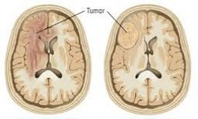

**Fig. 1.** Classification of healthy brain tissues and tumor brain tissue

The major contributions of this study consist of:

1. Incorporation of cutting-edge preprocessing algorithms such as Adaptive Contrast Enhancement Algorithm (ACEA), non-linear gamma enumeration tool, scaling, histogram modification, all within a single scan, to enhance image resolution and facilitate the extraction of features from MRI images.
2. Utilization of Fuzzy C-Means (FCM) segmentation for more accurate tumor

region extraction, along with Grey Level Co-Occurrence Matrix for reliable feature extraction.

1. Development of a hybrid CNN-SVM model for better classification and the

differentiation of brain tumors using MRI scans.

1. Comprehensive analysis of the effectiveness of this proposed model based on

dataset of MRI images, with comparisons to conventional methods.

1. Examination of different evaluation metrics to assess the performance and reliability of the suggested approach.

The accurate segmentation of tumor regions in MRI scans is crucial for an accurate diagnosis. Among many segmentation techniques, Fuzzy C-Means (FCM) clustering is widely applied, as it groups pixels of the image into clusters depending on the similarity in intensity for efficient tumor region identification. Further, the extraction of important texture features aided by the Gray-Level Co-occurrence Matrix (GLCM) gets added to the improvement of classification accuracy.

In view of a hybrid deep learning model for brain tumor detection, this method combines CNNs for feature extraction and SVMs for classification. Thus, by combining advanced machine learning techniques with optimized preprocessing, this model elevates tumor identification and proposes treatment options. The interface of such AI diagnostic tools within the clinical setup promises a marked improvement in the diagnosis and outcome for patients with brain tumors.

# Related Works

Brain tumor diagnosis and classification are approached from different angles in most studies, including that of S. Solanki. It recommends the effects of deep learning architectures such as Convolutional Neural Networks (CNNs) and transfer learning models such as ResNet-100 and VGGNet.Standard machine learning methods such as Support Vector Machines and Random Forests encounter a barrier of automation. Hence, such methods are not very compatible for scaling up work in analysis of medical images. CNN-based methods have been proven to make significant improvement ofclassification accuracies compared to other traditional methods by about 10%-15%. Furthermore, performance improvement by 5%-10% prediction accuracy is also gained via transfer learning, making it a great weapon in brain tumor diagnosis.

The proposed improved framework for brain tumor detection based on CNN is an integrated approach, which involves the Deep Convolutional Neural Network (DCNN) with a system of three pre-processing steps, and is put forward by M. Imran [4]. This framework has been shown to work better than standard models such as VGG16 and VGG19 in that it can tell more accurately for tumors. The whole process of noise reduction, intensity normalization, and enhancement of contrast provides for the pre-processed MRI images, which the model is able to extract the more relevant features from.

The review of advances in machine learning and deep learning especially for MRI-based tumor detection by Ahmad S. and Choudhury P.K. [5] elaborates that pre-trained architectures like Inception- V3 and DenseNet201 have reached accuracy levels beyond 90%. These systems still require optimization; therefore, research work should focus on hyper-parameter tuning, improvement of network architecture, and the integration of augmentation techniques for the dataset aimed at enhancing robustness and generalization.

To overcome the restrictions posed by single-modal imaging techniques, Shah H. A. [6] developed a CNN-based multi-modal MRI fusion approach, incorporating information from separate MRI sequences for the localization and classification of tumors. It calls for an even greater analysis with regard to complementary information extracted from T1, T2, and FLAIR-weighted images to improve diagnostic efficacy.

Compared to other models in studying brain tumors, EfficientNet - B0 has been mentioned as one of the best models for effective detection of brain tumors as revealed by [8]. The usage of transfer learning through augmentation is approached in cases of restricted MRI datasets. Different forms of data augmentation like rotation, flipping, or adjusting the contrast are introduced to reduce the overfitting and generalization of the model on different patient cases. M. Agrawal [9] developed a well-optimized deep learning framework for the detection and classification of brain tumors by using the Inception-V3 model for improving accuracy. This method has employed a deeper and better architecture used for feature extraction such that it can identify the tumour with much more accuracy and classify it.

In applying convolutional neural networks to improve accuracy of tumor classification using magnetic resonance images, Sireesha M. [10] made use of advanced computational techniques. This approach is actually helpful, as it provides high precision and accuracy in detecting brain tumors, which greatly improved the diagnostic precision in clinical applications. Recent developments have also investigated the use of object detection models to identify tumors. These tumors are identified with MRI-based Faster R-CNN [11] framework, which employs Region Proposal Networks (RPNs) in localizing tumors in real-time. This model has remarkable capabilities in reduction of the time for diagnosis, hence making it a good potential for radiologists' and medical professionals' use. Rapid and very precise segmentation of the tumor further makes it applicable in the real-world clinic environment-in the imaging and diagnostic workflow.

In general, combined approaches involving deep learning, transfer learning, and multi-modal images have been too far in the automated detection of brain tumors and in achieving improvements in diagnostic accuracy and efficiency, thus mitigating the challenges posed by limited data sets and the optimization of models.

Adding multi-modal imaging, whereby different MRI sequences such as T1, T2, and FLAIR images are combined, allows for a far more comprehensive assessment of brain tumors through the acquisition of various structural and textural pieces of information. It is through the fusion of various imaging modalities that tumor localization and classification gain the accuracy that translates into definite diagnosis. Further, advanced preprocessing measures like adaptive contrast enhancement, noise remove, and data augmentation it cleanse the input data, providing means for models to extract more relevant features and ultimately enhance general accuracy.

With the combination of these advanced technologies, automated brain tumor detection systems have become more reliable and more efficient than ever. These advancements reduce the workload on the radiologist even as they facilitate quicker and more accurate diagnoses, thus positively affecting patient outcomes and providing the ground for individualized treatment.

Hassan Ali Khan examines a CNN approach for differentiation of brain tumors in MRI images. An in-house CNN [21] model is compared with VGG-16, ResNet-50 and Inception-v3, which are pre-trained models. The proposed model , surpassing the other models in accuracy but consume less power. This clearly shows the capability of deep learning making medical images efficient and accurate.

This technology [22] has changed the game for brain tumor classification; MRI images that were previously manually analyzed for imaging features extraction were traditionally obtained through imager techniques such as ultrasound. Now that a new model has been developed, such as CNN, VGG-16, ResNet-50, these models are likely to improve accuracies even more than above.

Differential Deep-CNN [22] provides accuracy improvement of feature extraction and achieves up to 99.25% accuracy. In addition, multi-modal (T1, T2, FLAIR) MRI data has been used to develop hybrid models such as CNN-SVM to advance detection. When combined with transfer learning and data augmentation, the level of performance rises even higher.

This new research on MRI images [24] for brain-tumor classification seeks to address the need for high accuracy and efficiency. The traditional modeling approaches used manual feature extraction, whereas using CNN models such as VGG16, VGG19, or ResNet-50 gives an automated approach for tumor detection with high precision. Muhammad Attique Khan [24] proposed a method for multimodal classification incorporating MRI sequences (T1, T2, T1CE, and FLAIR), feature selections, and fusion methods; with the algorithms yielding 97.8% accuracy. Transfer learning and hybrid models (CNN-SVM, ELM, etc.) have improved classification performance.

Basically, deep learning methods have shown relevance towards more efficient and faster brain tumor detection than the traditional methods. This is an aid towards early diagnosis and timely treatment. Recent state of the art in deep learning is distinguishing itself in the operation of brain tumor classification using MRI images. Earlier methods had relied on somehow manual feature extraction, but the current techniques have been known to use all possible kinds of modern models like the CNN, ResNets, VGG, which works as effective automated tumor detectors with the greatest accuracy which is specific.

The amazing accuracy achieved is 99.83% with an outstanding performance on the ResNet101-CWAM [25] model, as compared to earlier deep learning techniques. Attention mechanisms-also referred to as channel-wise and spatial attention-augment feature extraction, thereby enhancing the classification accuracy. Transfer learning and hybrid architectures such as CNN-SVM and 3D-CNNs also increased the detection efficiency.

All in all, deep learning will bring fast, automatic, and very high-performance tumor classification to enable early diagnosis and improve patient quality of life.

Classification of brain tumors using MRI images has come to incredible advances through the introduction of several machine learning and deep learning models. Traditional models based on CNNs tend to extract their features from the last layer, whereas recent studies have noted that consideration of multi-layer feature aggregation might improve accuracy significantly.

An innovative approach combines a soft-attention mechanism [26], which ramp up feature selection by giving priority to the most clinically relevant information, and a four-layer convolutional neural network architecture, yielding robust tumor classification performance. Probing through comparative studies shows that this method outshines existing state-of-the-art models making it more hopeful towards precocious and accurate brain tumor diagnosis.

## Problem Statement:

Brain tumors quite serious, could cause paralysis and long term treatments. Their implications vary based on their size, location and type. Cerebral neoplasms have life-threatening consequences due to disabilities that are so serious requiring harsh drugs or surgeries just to curb pain and not treat them whatsoever. Brain damage consequence from any malignant growth usually depends on factors like its size; where it’s located within our system; what makes up this invasive agent- these are the things distinguishing one region from another (i.e., responsible for movement). An effective measure against some impairments would be early diagnosis because once they start appearing; you cannot go back anymore! Nevertheless, though challenging enough to achieve, accurately classifying brain tumors is challenging because there exists vast diversity among them regarding volume ratio or lightness color differences arising from mere instinct alone! Henceforth since some kinds of malignant growths show certain external resemblances, it becomes hard to classify them properly. There are serious consequences of having a tumor such as disabilities that may be severe and can lead to long-term treatments which are painful with the aim of either curing or alleviating one’s impairment. The possibility for normal function depends on several factors, including size and location (i.e., on the surface) as well as the type of the tumor. For example, specific areas of the brain that control limb movements could get compressed by tumors making it impossible to move around at all. Early diagnosis is important in order to prevent or minimize such disabilities from occurring. However, the fact that brain tumors can be of different types and sizes whose shapes also differ makes it difficult to classify them accurately in terms of pathology. To overcome these barriers to accurate diagnosis and treatment, which would consequently enhance patients’ outcomes and improve their lives quality wise, it is essential that we have effective tools for diagnosing them promptly.

Early diagnosis prevents complications. There is therefore a need for better instruments for quick, precise diagnosis to facilitate prompt treatment with improved out comes for patients.

# Proposed methodology

The purpose of this research work is, therefore, to build an automated system for brain tumor detection in MRI images[12] using a combination of deep learning techniques and traditional machine-learning techniques[14]; see Fig 3. Since tumor identification requires an early and accurate intervention, this method combines many sophisticated computational methods together to increase detection accuracy and reliability.

Detection starts with preprocessing, which helps improve image quality via the Adaptive Contrast Enhancement Algorithm and median filtering. These processes enhance the visibility of the tumor by varying the contrast, reducing the noise levels, and retaining important details of the image so that the model is presented with quality input data. At this stage, image segmentation is done using the Fuzzy C-means clustering algorithm, which assists in most effectively separating tumor regions from surrounding brain tissue.

This clustering type segmentation technique uses pixel intensities and clusters a set of pixels together based on similar intensity values for the precise extraction of the tumor area. Then, following the segmentation, key feature extraction methods are required to express relevant information about the tumor.

The Gray-Level Co-occurrence Matrix exists for examining texture patterns, which includes essential parameters as contrast, correlation, energy, and homogeneity. All these features 'discovered' will help to approximate the structure of the tumor, as required in classification. The concluding phase entails the application of a hybrid deep learning model effectively amalgamating the Convolutional Neural Networks and the Support Vector Machines to classify the features extracted. While the CNN learns and extracts automatically deep spatial feature transformations, the SVM then classifies the learned representations with potentially high precision. Because of the evidence through the application of CNN and SVM techniques, the recognition of complex patterns can be effectively handled by such deep networks as the CNN, whereas the complex high-performance classification systems facilitate much identification of outputs from the SVM, which ultimately works towards increasing the tumor detection accuracy.

It makes for a more comprehensive and sound diagnostic system, which tends to call less on manual interpretation for the reading to assist the radiologists much better in determining from observations made.

## Dataset collection:

To assess the efficacy of the model we propose, experiments were carried out on a publicly accessible dataset from Kaggle [2]. This dataset consists of T1-weighted contrast-enhanced MRI scans [7] from brain tumor patients, as illustrated in Fig. 5. So, this dataset is a good, well-structured, and varied one of MRI images of considerable value for use as a benchmark to train and validate deep learning models on tumor detection and classification.

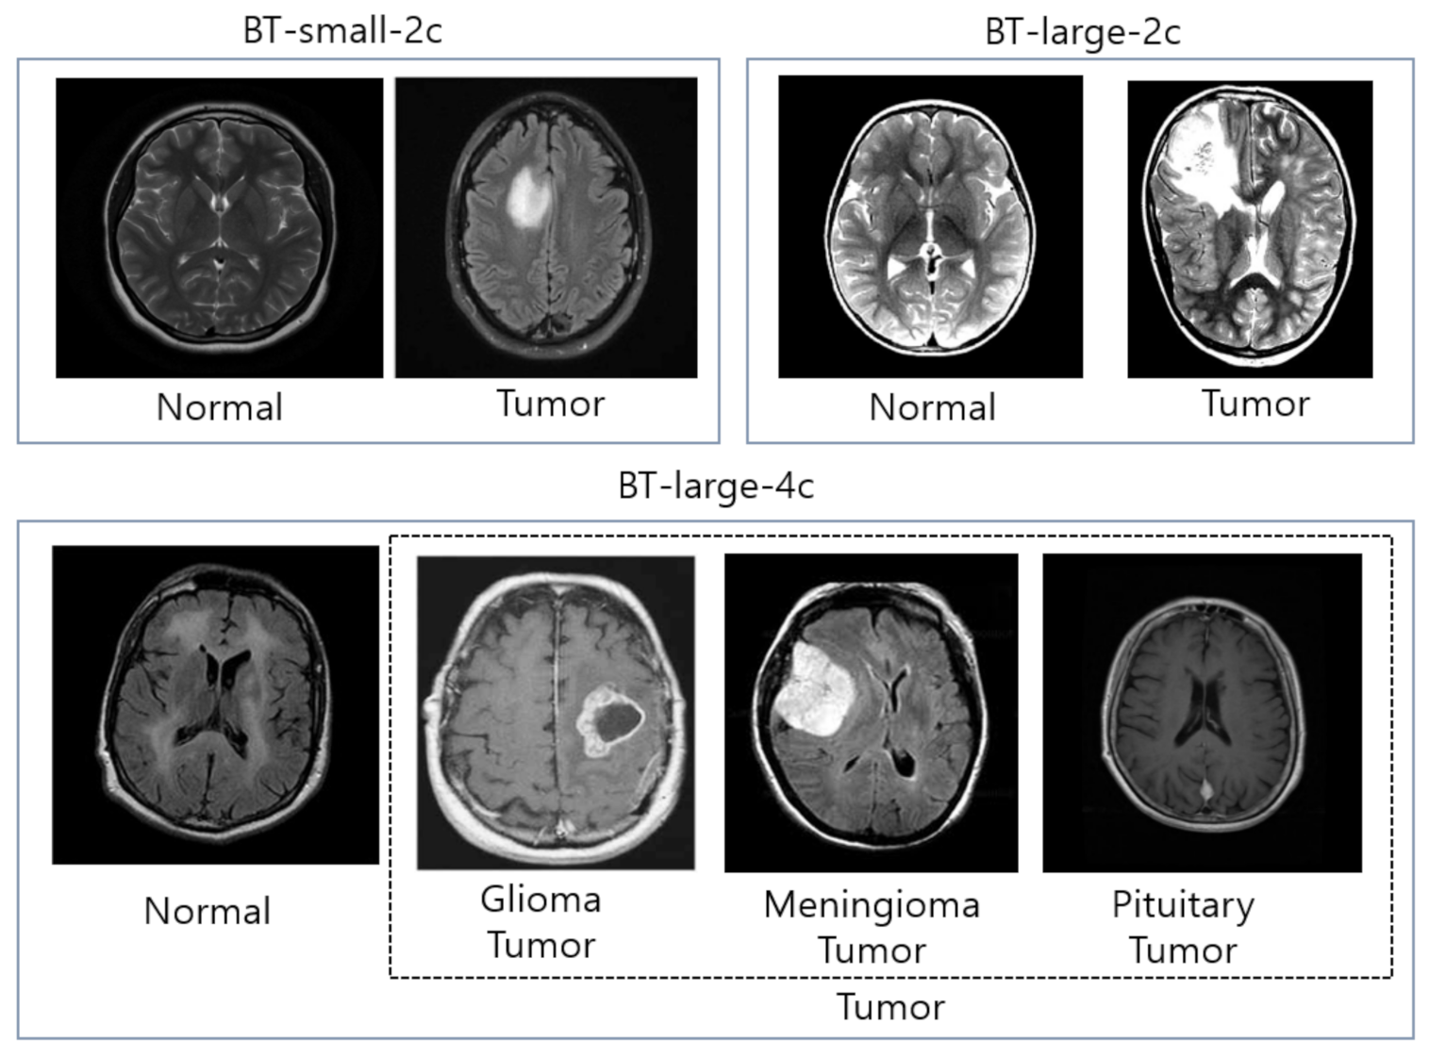

Fig 2. Different types of tumor in dataset

**Four specific categories of MRI slices included in the dataset as shown in Fig 2:**

* Meningioma – The kind of tumor that arises in the protective membranes that cover the brain and spinal cord.
* Glioma - The most harmful and common tumor of the brain that arises from glial cells, which are responsible for supporting neural function.
* Pituitary Tumor - Growth in the pituitary gland; many times hormonal and neurological functions become disturbed.
* No Tumor - MRI slices without any detectable tumors in them so that the model is trained to differentiate between healthy and sick scans.

This dataset contains PNG formats of MRI images acquired from: https://www.kaggle.com/datasets/vivekp7039/figshare-brain-tumor-dataset-converted-to-png. It is helpful preprocessing and easier model training. The dataset offers high-quality and well-annotated images for a fine benchmarking scenario of DEEP LEARNING CLASSIFICATION MODEL.

The proposed study intends to take advantage of this dataset by enhancing the accuracy of tumor detection with a quality preprocessing pipeline, suitable features extraction techniques, and an optimized adaptive hybrid CNN-SVM classification model. The proposed tumor features will give an additional advantage as it incorporates several tumor types, ensuring that the detection model can successfully differentiate between different tumor types for a better automated and accurate medical diagnosis.

## Preprocessing:

**ACE - Adaptive Contrast Enhancement Algorithm (improvised algorithm)** ACE algorithm one of the techniques used to increase the contrast in images by taking into account the local statistical properties of pixel intensities like mean and standard deviation within certain parts of an image. This makes it possible for more accurate adjustments hence improving its overall appearance by aligning contrast enhancement with features found in specific areas rather than using a one size fits all system. In general, the main aim of ACE is to enhance image clarity through different levels of contrast alteration on different areas. For instance, ACE examines local intensity variations thereby ensuring that each area has appropriate amount of contrast adjustment. It improves clarity and aesthetics of an image by targeting specific demands posed by various sections therein.

The first step is to slice the picture into segments for localized contrast mod- ification by(1).

(1)

Next, we calculate the standard deviation, the mean using (2):

(2)

After gathering local averages and standard deviations (equations 1 and 2), as in (3). The modified pixel value can be expressed by this formula:

*p*new = *µ* + *k ·* (*p − µ*) (3)

Where 𝑝𝑛𝑒𝑤is indicated as new pixel intensity (3), ( 𝜇) is local mean (1), (p) is old pixel value (3)

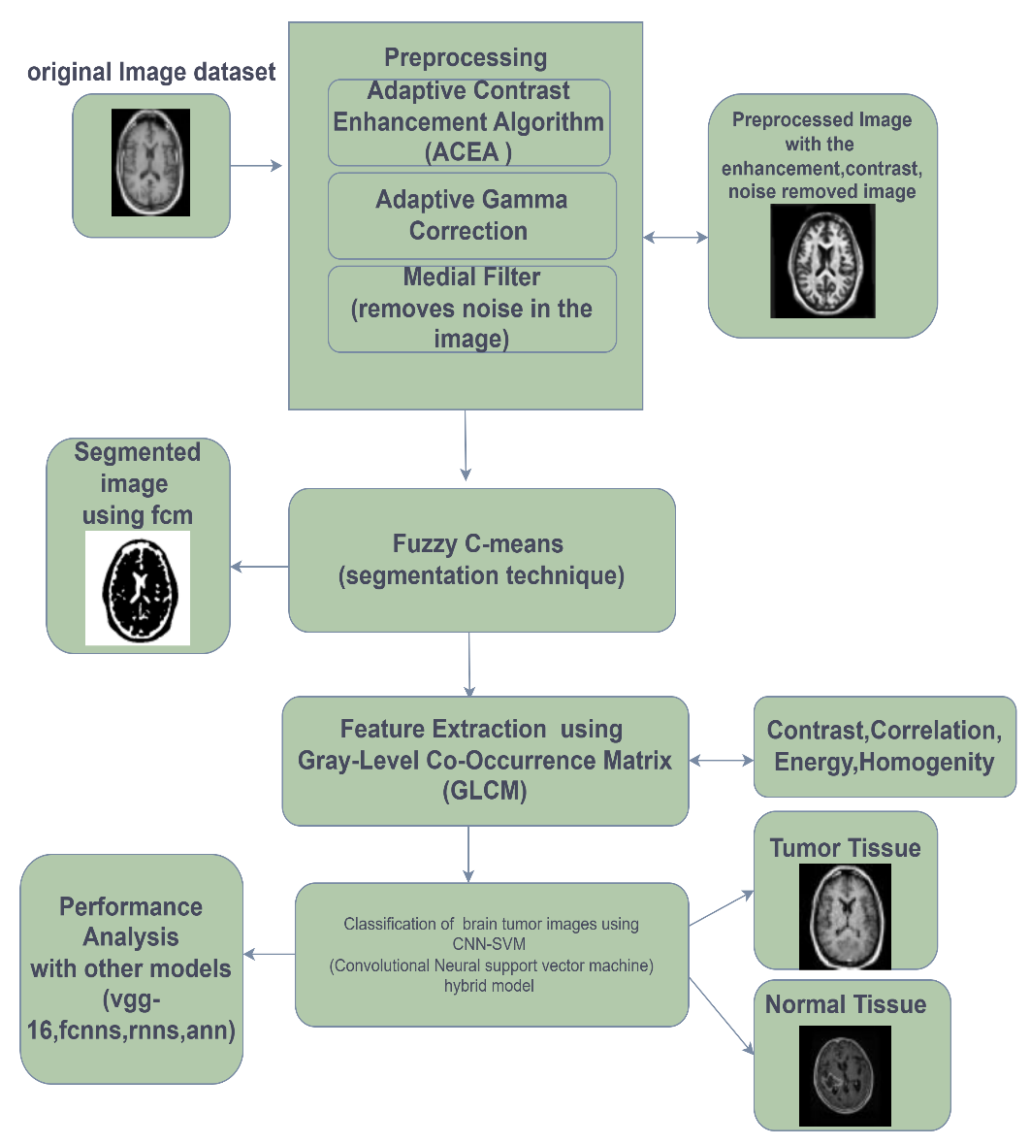

**Fig. 3.** Procedure Outline for the Developed Technique.

**3.3 Adaptive Gamma Correction Algorithm(AGC):**

AGC alters brightness and contrast locally to enhance MRI scans for brain

tumor detection; it enables better visualization of tumors than their neighboring tissues. In contrast to conventional gamma correction, AGC adjusts the value of gamma for each zone. The formula used to determine the corrected pixel intensity *I*corrected (4) is as follows:

*I*corrected(*x, y*) = *I*(*y*)*γ*local (4)

this is the formula(4) used to convert pixel intensities that may be expressed as ‘i’ and ‘local gamma’ value - represented as, which is inversely proportional to distance. The correction preserves brightness in darker areas people-colored objects appear less white. When MRI pictures undergo Adaptive Gamma Correction (AGC), the output images turn out clearer and have greater resolution than before hence improving tumor identification as well as ensuring better diagnostic accuracy leading to effective management of diseases. To obtain clear, high resolution images, AGC is used to increase local gamma value, *gamma*local, in MRI images

**3.4 Median filter:**

This is the most renowned strategies for removing and clearing noise in digital pictures and signals is median filtering [17] that is widely recognized because it is efficient against “salt-and-pepper” noise, where some pixels become incredibly brighter or darker than neighboring pixels. This technique is meant to help clean up an image with excess noise while keeping vital information intact. The method involves shifting a window, the normal sizes being either 3x3 or 5x5, across the picture or signal. The Centre point pixel of this window has its value replaced by the mean of the other pixels in that particular location at each position around it. To arrive at an average, one first sets up a list containing all values that are involved; if there are two then one takes those two numbers at the Centre point; then this means new value obtained after filtering will be

*u*updated(*a, b*) = median*{p*(*a − m, b − n*)*, . . . , p*(*a* + *m, b* + *n*)*}* (5)

Here, *u*updated(*a, b*)(5)represents the new parameter of (a, b) where (a,b) is the updated parameter of the pixel at position (a, b). This median takes account of the pixel values gathered from a window around (a, b) such that k represents half the window size.

* Median filtering is one popular image processing non-linear technique used in preprocessing for brain tumor detection and classification. It discards noise from the medical images, especially the MRI scans, without sacrificing the crucial details of the image concerning the shapes of the tumors, making it a very effective technique. Thus, it dramatically improves the quality of the image prior to its use in some complex applications like CNNs and SVMs for tumor detection and classification.

## 3.5 Enhanced Image Segmentation Through Fuzzy C-Means Clustering:

Fuzzy C-Means (FCM) [23] segmentation is an often-used unsupervised clustering technique Certainly, brain tumors can be detected and segmented using fuzzy c-means method (FCM) as show in Fig 4. This is an improvement over conventional methods be- cause FCM takes into account the inbuilt fuzziness of data unlike traditional techniques that apply hard classifications.

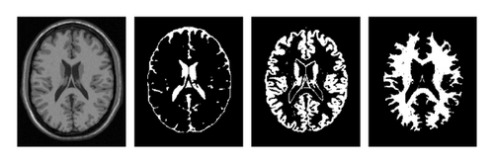

**Fig. 4. Result of FCM on original MRI scans**

In the process of Cluster Centre Computation, new cluster centers are computed

through the formula (6):

(6)

Then, update the membership values based primarily on the distance between data points and cluster centers (6) using the formula:

(7)

The objective function can be calculated to check for convergence using formula (8):

(8)

This process ends when it reaches a predetermined level of the objective function

(8) or when it has carried out its maximum number of iterations. Otherwise, the processes are repeated.

## Feature Extraction using GLCM :

A gray level co-occurrence matrix known as GLCM is a common textual study method that examines spatial correlations of pixel intensities in MRI images. This statistical technique captures texture information, helping to differentiate tissues and detect pathological features like tumors in medical MRI scans.

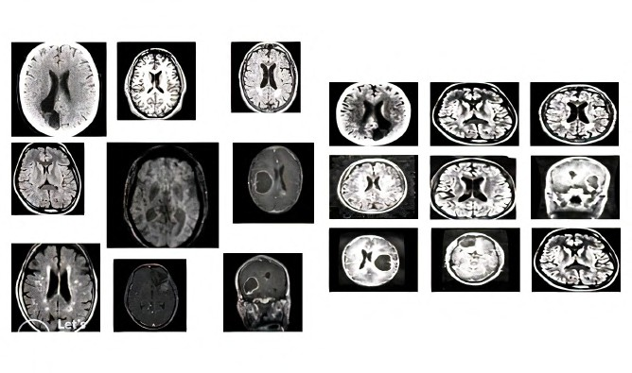Following several statistical features can be obtained from GLCM to characterize the MRI image texture. In this approach was suggested, contrast, dissimilarity, homogeneity, energy, correlation, image texture.

**Fig. 5.** Comparisons of Different and Same Sizes Sample MRI

GLCM texture features are instrumental in brain tumor detection because they can yield patterns that signify the presence of a tumor. These features are known to be synonymous with the texture changes resulting from the tumors as tumors tend to exhibit unique textural features that differ from that of the entourage. The diseased heterogeneous disorder within malignant tumors often contrasts the regular homogeneous health brain tissues.

The textural features obtained from the MRI images are the most important features necessary for the machine learning models, like CNNs and SVMs, for the easy classification of tumor/non-tumor images. The Gray-Level Co-occurrence Matrix (GLCM) is of paramount importance in the field of medical imaging when it generally comes to detecting tumors present in the brain, and it provides a matrix for identifying healthy and tumorous brain tissue based on their texture patterns.

GLCM features become a very powerful tool to improve tumor detection systems and would greatly enhance the diagnostic accuracy if these features are combined with machine learning algorithms to a level where the tumor classification would become economical and reliable and aid the clinicians in making good decisions from the diagnostic perspectives.

* Contrast: It measures the intensity difference among neighboring pixels. A higher contrast value from (9) which may be useful in differentiating tumor areas from normal tissue.

Higher contrast value from (9) indicates greater transcriptional variability, which may be useful in differentiating tumor areas from normal tissue.

* Correlation: In an image, correlation measures of how much image data points(pixels) are related linearly to one another. This indicative bare skeleton measure (10) indicates how intensity correlates with the pixel map of different positions in any given place. (10)

* Energy: It represents (11) the combination of the class features in the GLCM, which means that the text is identical. It quantifies the sum of squares of the elements in the matrix representing the order of textural homogeneity in an image.

(11)

While distinguishing tumor and non-tumor areas from each other, energy is capable of analyzing the consistency of pixel arrangements in MRI scans for brain tumor detection.

* Homogeneity: In (12) measures how close the distribution of features in the GLCM is to the diagonal.

(12)

The greater the homogeneity value, the more uniformly the intensities in an image are distributed, having very little variation between neighboring pixels. Along with analyzing the others, homogeneity refines models in medical imaging to investigate the properties of various tissue structures and thus assist in the precise classification of brain tumors.

## Integrated Hybrid Models With CNN and SVM for Enhanced Classification:

This model integrates the feature extraction of CNN neural network with the classification of SVM; hence optimizing image analysis and category boundaries. This model combines the feature extraction capabilities of a CNN with the classification power of a SVM to improve the accuracy and performance of the brain tumor detection. Being an automatic learner, the CNN learns hierarchical features from MRI images, and encodes valuable information about the spatial and structural aspects of the images. However, while CNNs win hands down on feature learning, sometimes classifier efficiency could be improved when a more specialized classifier is included.

To form better decision surfaces and perform better categorization, the classifier is SVM in this model. SVM is a very strong machine learning algorithm that incarnates the optimal hyperplane to differentiate among various tumor classes by maximizing the margin between the respective categories. By incorporating CNN and SVM, it is possible for this model to utilize the deep high-dimensional feature extraction capabilities of CNN and effectively deal with complex nonlinear classification tasks through SVM.

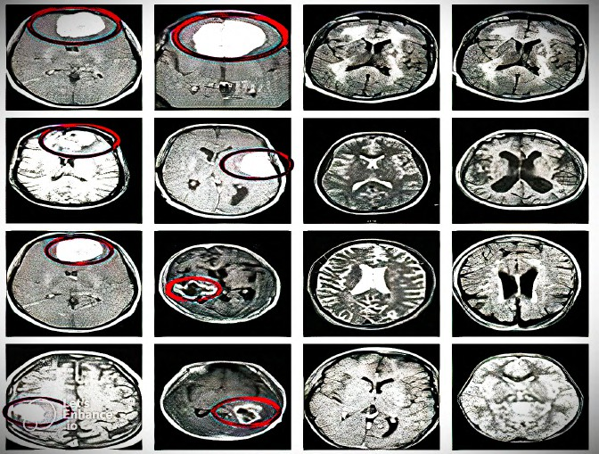The hybrid method then optimally refines image analysis by strengthening feature representation and boundary crispness, leading to a successful means of discriminating different types of brain tumors, namely gliomas, meningiomas, pituitary tumors, and non-tumor cases. The integration of CNN and SVM gives rise to a strong and precise classification system that may be a tool for increased diagnostic accuracy and reliable medical decision-making as shown in Fig 6.

**Fig. 6.** Hybrid CNN-SVM Model for identifying tumor and non tumor images

**Designing Approach for Hybrid CNN - SVM system:**

The CNN-SVM model in it, various raw images are passed through a CNN [13] where rectified linear unit (ReLU) activations and pooling layers help to maintain important information while reducing dimensions. After that, a fully connected layer(13) compresses the flattened output which is then classified by the SVM machine learning model that searches for the best hyperplane for class separation.

**Implementation of CNN-SVM Hybrid Model Architecture:**

In order to effectively create a CNN-SVM structure , the initial step is teaching a CNN using a loss function, for instance cross entropy loss, in order to achieve the extraction of useful features.

**Training of the CNN:** To come up with features, one can create a CNN [19,20] that will minimize a loss function (like cross entropy loss) based on (14) equation in accord to features representation. For this reason, a set of image segmentation activities can be listed here as those which will yield precise results.

This training consists of image segmentation which improves the feature ex- traction and the entire system performance(14).

(14)

**Training of the SVM:** After training on samples, we will apply them for supervised learning by using support vector machine models. This is accomplished through quadratic optimization; it searches for an appropriate hyperplane within feature space that maximizes distance between different classes. In other words, by combining these two components into one system (i.e. CNN-SVM model), we hope accuracy as well as generality would improve greatly since while the former lacks smartness in terms of pattern recognition ability when compared against the latter which is simply multi-purpose but often inefficient.

The combination of CNNs and SVMs into a single system can be used to take benefits from both methods thereby creating a better, more accurate, and generalized model of brain tumor detection. The CNN'S feature extraction, however, did not yield the best final classification results when used alone, especially since attention on deep learning representation may be weak in most cases, especially in small and imbalanced datasets, by contrast, while SVM is approached by small examples. While SVM creates a very well defined class boundary, SVMs as multiclass classifiers are very useful in medical image classification activities, where precision is top within.

This hybrid architecture CNN-SVM is thus able to really increase accuracy and generalization. The pattern recognition is done by CNN, while SVM fine-tunes it by sharpening the decision boundaries and reducing the errors. By this coherent integration, the model becomes better robustly against the deficiency of CNN in classification and against the inefficiency of traditional SVM in processing raw image data. In other words, this approach makes tumor detection more reliable so that it can improve early diagnosis and help in making better clinical decisions for improved patient outcome.

* 1. **Developing the CNN-SVM Hybrid Model A Training Methodology:**

The training mode for CNN-SVM hybrid model uses dual optimization strategy making use of the two. The CNN [11] is initially trained to extract feature vectors from input MRI images. These are fed into SVM [15] for classifying purposes. This system performs alternating updates of both CNN and SVM based on metrics results than when only CNN or SVM were used separately. The developed model identifies and detect the tumor as shown in Fig 4 efficiently.

In contrast to other models using either CNN or SVM, the performance of this hybrid scheme improves by dual optimization. This system complements CNN, as it may not effectively determine the optimum decision boundaries for a standalone classifier, while classical SVM classifiers are inefficient with raw image data. This approach makes the proposed model of CNN-SVM very efficient in brain tumor identification and detection in terms of accuracy, reliability, and robustness for the classification of medical images. As depicted in Fig 4, the system successfully detects tumors with higher precision, making it a promising tool for automated early diagnosis and clinical decision-making

This hybrid algorithm, combining the power of CNNs in fully automated feature extraction and SVMs in classifying these extracted features fused into an image, results in a robust and strong method for tumor detection within MRI images. Through iterative training and fine-tuning alternating phases, progressively the model starts achieving learning towards accurately discovering features that distinguish one tumor type from another. This enables the model to regulate an optimizing of both the feature extraction of the CNN and classification by SVM in an efficient, accurate brain tumor detection system.

* 1. **Model Output:**

The outcome model of CNN-SVM combine CNN to extract features and SVM ,The model possesses an astoundingly high prediction accuracy of 97.94% through the employment of this dual technique, as depicted in Fig 7. The outstanding performance of the architecture, facilitated by the weight of this distinction, arises from the ability of CNNs to deal with complex image data and SVMs to optimize the decisions at boundaries separating tumor classes.

In contrast to common deep learning models, where final classification is done through layers of fully connected architecture, the introduction of SVM promotes the generalization of the entire system and reduces chances of overfitting.

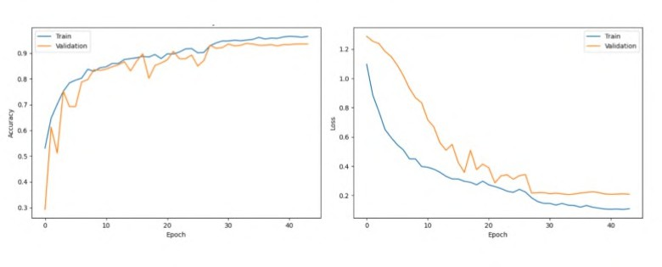

**Fig. 7 Performance Analysis of CNN-SVM Model**

This result shows right and relevant evidence that the CNN-SVM basically performs outstandingly in discriminating between different types of brain tumor cases, such as gliomas, meningioma, and pituitary tumors, as well as non-tumor cases. Such high accuracy is an indication of the potential of this technique in clinical applications. As such, it is an efficient, automated, and highly accurate means for early diagnosis of brain tumors.

# Results and Discussions:

Using Python 3.10 based deep learning or Machine Learning methods, this section is devoted in brain tumor detection from MRI images. The evaluation of models has been done through TP, TN, FP and FN metrics that compare CNN-SVM model with other models such as CNN, VGG, RNN, RFC, FCNN and ANN. Accuracy, Jaccard index as well as sensitivity are used to measure performance.

The combination of DLand ML techniques for brain tumor detection has remained a flagship in this field with great efficacy. Among the tested models, predominantly CNN-SVM hybrids perform far better than CNNs or RFCs as single entities when it comes to accuracy, sensitivity, and the Jaccard index, thus embracing additional advantages from to minimize feature extraction of the CNNs and strong classification capabilities of the SVM in tandem to retain high tumor detectability results, which are usually pertinent for early diagnosis and treatment. Yet, they all have their clinical benefits and would be designed using a specific combination of the needs of the application, specific characteristics of the dataset, and desired performance metrics.

## Accuracy

The capability of a model in effectively classified between tumor types and normal tissue is referred to as the accuracy(15).It is a key metric for measuring performance.

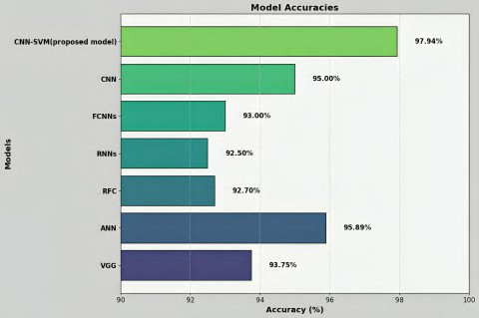

**Fig. 8.** Accuracy comparison.

Comparing the suggested method shows clearly higher accuracy [18] at 97.94% as shown in Fig 8.

Accuracy = *TP* + *TN* (15)

*TP* + *TN* + *FP* + *FN*

TP (True Positives): Detecting tumor instances correctly is the number of TP cases.

TN (True Negatives): In this case, TN cases refer to those non-tumor cases that have been detected accurately.

FP (False Positives): The number of non-tumor cases wrongly classified as cancerous are referred to as FP cases.

FN (False Negatives): There are a variety of reasons why patients might miss out on timely diagnosis; therefore, FN cases involve the situation where a patient is thought not to have a tumor but really does.

## Specificity:

Specificity(16) measures the proportion of true negatives, indicating how well a test identifies the absence of disease. As shown in Fig 9, CNN-SVM achieved the highest specificity of 98.1 %, excelling in MRI classification.

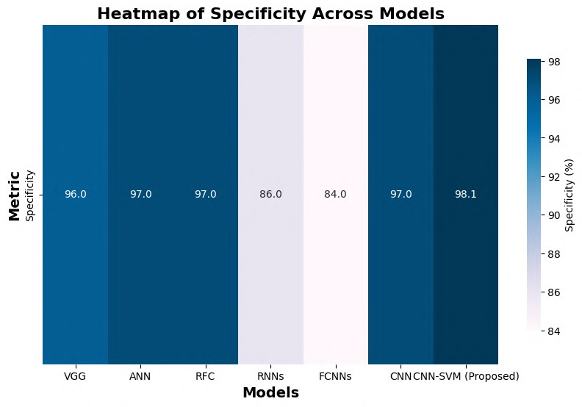

**Fig. 9.** Specificity comparison.

## Sensitivity:

True positive probability is what sensitivity assesses. In the design of the CNN- SVM model, the sensitivity value(17) was obtained as minutely as 95% which exceeds that of traditional approaches.

As shown in Fig 10, CNN-SVM achieved the highest specificity of 98.1 %, excelling in MRI classification.

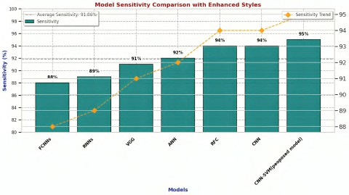(17)

**Fig. 10.** Sensitivity Comparison.

## Jaccard Coefficient

Jaccard coefficient, commonly referred to as the Jaccard index or intersection over union (IoU) (18), is a primary measure in image segmentation and analysis. Here, Fig 11 shows Jaccard index of the analysis of the different models.

* p stand for segments of pixels in proposed tumor zone.
* q is used to refer to the true tumor parts.

The intersection of p and q is the predicted tumor areas and actual tumor areas (in contrast, the areas correctly identified as tumor by model). The union of p with gives rise to the actual tumor and predicted tumor regions (wherein those pixels belonging either to predicted tumor or real one represents everything).

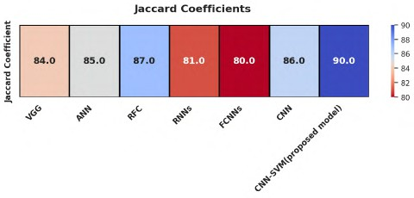

**Fig. 11.** Jaccard Coefficient.

Each model has its advantages. CNNs are very effective for image classification - they learn the features automatically and also perform well in detecting brain tumors. VGG is a type of deep CNN that also captures good performance by capturing fine-grained features. RNNs, however, are for sequential data; single MRI images are not used to that extent with RNNs applications. Whereas RFC and ANN are machine learning models that depend on the features as a strong solution within these two MCs but cannot match CNN for direct classification from images. FCNNs are specific for pixel-wise classification, which makes them useful for tumor segmentation tasks. If we consider all these models at a time, then the CNN-SVM hybrid gives the state-of-the-art performance in terms of accuracy and sensitivity due to feature extraction and classification abilities combined into one application. Each of these methods has its own advantages, but the highest accuracy and reliability in tumor detection generally come from the deep learning models.

# Discussion:

Table 1 explains about the performance measures of several ML and DL models are compared. These techniques include CNN, ANN, RFC, RNN, FCNN among others and the proposed model CNN-SVM plus the VGG architecture. Though each model has its level of accuracy, speed and overall performance, the costs in terms of computational power also differ across the models. For example, high-performance ANN models require sophisticated hardware where they are deployed and are dependent on tuning of hyper qualities which often results to differences in their performances. Random Forest Classifiers have a reputation for being versatile and capable of dealing with diverse data, the ensemble methods tend to be expensive in terms of computing power as the number of trees increases which in most cases leads to delays especially with bigger data sets. RNNs are great for tables and graphs that have all the data points in a particular order, but they cannot handle farther back gaps so well and tend to be heavier on the processing.

**Table 1. Analyzing Model Accuracy for MRI-Based Tumor Detection**

|  |  |  |  |  |
| --- | --- | --- | --- | --- |
| Model | Accuracy  (%) | Jaccard Coefficient  (%) | Sensitivity (%) | Specificity (%) |
| VGG | 93.75 | 84 | 91 | 96 |
| ANN | 95.89 | 85 | 92 | 97 |
| RFC | 92.70 | 87 | 94 | 97 |
| RNNs | 92.5 | 81 | 89 | 86 |
| FCNNs | 93 | 80 | 88 | 84 |
| CNN | 95 | 86 | 94 | 97 |
| **CNN-SVM (Proposed)** | **97.94** | **90** | **95** | **98.1** |

To classify data points utilizing a CNN-SVM hybrid model tuned for feature extraction using a CNN and classification using an SVM, this becomes time-efficient and performs well. Both methods complement each other, allowing for improved accuracy and precision of classification.

A thorough study on performances including accuracy, specificity, sensitivity, and Jaccard's index results presented across datasets as shown in Figures 8,9,10,11 shall performance depicted by each model under several scenarios. The comparative visual analysis shall again validate the extreme effectiveness of CNN-SVM as its advantages over other classifiers..

# Conclusion:

Developed CNN-SVM model is very effective at detecting brain tumors with an accuracy of 97.94% Through advanced types of deep neural networks enabling easier approach to automatic feature extraction by using a supporting vector ma- chine classifiers combination, it becomes quite simpler than traditional methods thereby offering faster and easier way out. This model was found by simulations to have potential for better accuracies, and future researchers should focus on incorporating it into clinical software by using color images or 3D scans in order to achieve better tumor segmentation. Simulations have shown how vi- able this method is thus promising improved accuracy levels in regard to brain tumor detection using CNN-SVM models. Future research here is most important however; incorporating these algorithms into clinical software would enhance their practical uses in hospitals while working with colored photographs or three-dimensional scans could also assist better tumor segmentation leading to a more comprehensive instrument for diagnosing and planning treatment of brain tumors. As a whole, the CNN-SVM model is a promising step forward in the detection of brain tumors; it includes hybrid approaches that utilize deep learning techniques as well as machine learning ones for effective and accurate results. To enhance its usefulness in medical imaging, subsequent studies must seek to diversify its usage and implement it in health care systems.

And simulations have proven that it is a viable and effective way to say that CNN-SVM models can give an advantage in accuracy over conventional methods when detecting and localization of brain tumors. If adopted into clinical practice, it will not only allow faster tumor detection but also help make better treatment options to be given. Besides, the hybrid nature of CNN and SVM of combining DL and ML techniques promotes their future scope in medical imaging. On the other side, this requires further development for real-world clinical applicability to turn it into a very promising tool in the future of medical imaging.

The actualization of CNN-SVM models in medical establishments could facilitate an extraordinary advance in the mode of diagnosis bearing high potentials for accurate, rapid, reliable tumor diagnosis. Putting this together with some of the future developments of these technologies into health systems will greatly enable the lives of medical professionals in making better diagnosis, treatment planning, and patient outcomes. However, large-scale real-time clinical applicability, incorporation of 3D data for improving presentability of the displays, and incorporation within current hospital workflow patterns have to be included in future research before the model could be entirely adapted. It will definitely change the picture of the medical imaging one day because the growing technology will have revolutionary impacts on early detection of brain tumors - making itself a widely used and indispensable technology in hospitals around the world.

# References

1. S. Solanki, U. P. Singh, S. S. Chouhan, and S. Jain, “Brain tumor detection and classification using intelligence techniques: an overview,” *IEEE Access*, vol. 11, pp. 12870–12886, 2023.
2. S. Anantharajan, S. Gunasekaran, T. Subramanian, and R. Venkatesh, “MRI brain

tumor detection using deep learning and machine learning approaches,” *Measure-* *ment: Sensors*, vol. 31, p. 101026, 2024.

1. N. Noreen, S. Palaniappan, A. Qayyum, I. Ahmad, M. Imran, and M. Shoaib, “A

deep learning model based on concatenation approach for the diagnosis of brain tumor,” *IEEE Access*, vol. 8, pp. 55135–55144, 2020.

1. M. I. Razzak, M. Imran, and G. Xu, “Efficient brain tumor segmentation with

multiscale two-pathway-group conventional neural networks,” *IEEE Journal of* *Biomedical and Health Informatics*, vol. 23, no. 5, pp. 1911–1919, 2018.

1. S. Ahmad and P. K. Choudhury, “On the performance of deep transfer learning

networks for brain tumor detection using MR images,” *IEEE Access*, vol. 10, pp. 59099–59114, 2022.

1. M. Li, L. Kuang, S. Xu, and Z. Sha, “Brain tumor detection based on multimodal information fusion and convolutional neural network,” *IEEE Access*, vol. 7, pp. 180134–180146, 2019.
2. H. A. Shah, F. Saeed, S. Yun, J. H. Park, A. Paul, and J. M. Kang, “A robust approach for brain tumor detection in magnetic resonance images using finetuned efficient net,” *IEEE Access*, vol. 10, pp. 65426–65438, 2022.
3. A. Younis, L. Qiang, Z. Afzal, M. J. Adamu, H. B. Kawuwa, F. Hussain, and H. Hussain, “Abnormal Brain Tumors Classification using ResNet50 and its Compre- hensive Evaluation,” *IEEE Access*, 2024.
4. M. Agarwal, G. Rani, A. Kumar, P. Kumar, R. Manikandan, and A. H. Gandomi, “Deep learning for enhanced brain tumor detection and classification,” *Results in Engineering*, vol. 22, p. 102117, 2024.
5. Jagannadham, S. L., Nadh, K. L., Sireesha, M. (2021, November). Brain tumour detection using cnn. In 2021 Fifth International Conference on I-SMAC (IoT in Social, Mobile, Analytics and Cloud)(I-SMAC) (pp. 734-739). IEEE.
6. R. Ezhilarasi and P. Varalakshmi, “Tumor detection in the brain using faster R- CNN,” in *2018 2nd International Conference on I-SMAC (IoT in Social, Mobile, Analytics and Cloud) (I-SMAC)*, pp. 388–392, IEEE, August 2018.
7. A. A. Radhi, “Efficient algorithm for the detection of a brain tumor from an MRI image,” *International Journal of Computer Applications*, vol. 975, p. 8887, 2017.
8. M., Ergen, B., Cömert, Z. (2020). BrainMRNet: Brain tumor detection using magnetic resonance images with a novel convolutional neural network model. Medical hypotheses, 134, 109531.
9. Sharma, K., Kaur, A., Gujral, S. (2014). Brain tumor detection based on machine learning algorithms. International Journal of Computer Applications, 103(1).
10. Moturi, Sireesha, SN Tirumala Rao, and Srikanth Vemuru. "Optimized feature extraction and hybrid classification model for heart disease and breast cancer pre- diction." International Journal of Recent Technology and Engineering 7, no. 6 (2019): 1754-1772.
11. Greeshma, B., Sireesha, M., Thirumala Rao, S. N. (2022, February). Detection of arrhythmia using convolutional neural networks. In Proceedings of Second In- ternational Conference on Sustainable Expert Systems: ICSES 2021 (pp. 21-30). Singapore: Springer Nature Singapore.
12. Islam, M. K., Ali, M. S., Miah, M. S., Rahman, M. M., Alam, M. S., & Hossain, M. A. (2021). Brain tumor detection in MR image using super pixels, principal component analysis and template-based K-means clustering algorithm. Machine Learning with Applications, 5, 100044.
13. Amin, J., Sharif, M., Yasmin, M., & Fernandes, S. L. (2020). A distinctive approach in brain tumor detection and classification using MRI. *Pattern Recognition Letters*, *139*, 118-127.
14. Abiwinanda, N., Hanif, M., Hesaputra, S. T., Handayani, A., & Mengko, T. R. (2019). Brain tumor classification using convolutional neural network. In *World Congress on Medical Physics and Biomedical Engineering 2018: June 3-8, 2018, Prague, Czech Republic (Vol. 1)* (pp. 183-189). Springer Singapore.
15. Seetha, J., & Raja, S. S. (2018). Brain tumor classification using convolutional neural networks. *Biomedical & Pharmacology Journal*, *11*(3), 1457.
16. Khan, H. A., Jue, W., Mushtaq, M., & Mushtaq, M. U. (2021). Brain tumor classification in MRI image using convolutional neural network. *Mathematical Biosciences and Engineering*.
17. Abd El Kader, I., Xu, G., Shuai, Z., Saminu, S., Javaid, I., & Salim Ahmad, I. (2021). Differential deep convolutional neural network model for brain tumor classification. *Brain Sciences*, *11*(3), 352
18. Panda, B., & Panda, C. S. (2019). A review on brain tumor classification methodologies. *Int J Sci Res Sci Technol*, *6*, 346-359.
19. Khan, M. A., Ashraf, I., Alhaisoni, M., Damaševičius, R., Scherer, R., Rehman, A., & Bukhari, S. A. C. (2020). Multimodal brain tumor classification using deep learning and robust feature selection: A machine learning application for radiologists. *Diagnostics*, *10*(8), 565.
20. AG, B., Srinivasan, S., P, M., Mathivanan, S. K., & Shah, M. A. (2024). Robust brain tumor classification by fusion of deep learning and channel-wise attention mode approach. *BMC Medical Imaging*, *24*(1), 147.
21. Mohanty, B. C., Subudhi, P. K., Dash, R., & Mohanty, B. (2024). Feature-enhanced deep learning technique with soft attention for MRI-based brain tumor classification. *International Journal of Information Technology*, *16*(3), 1617-1626.